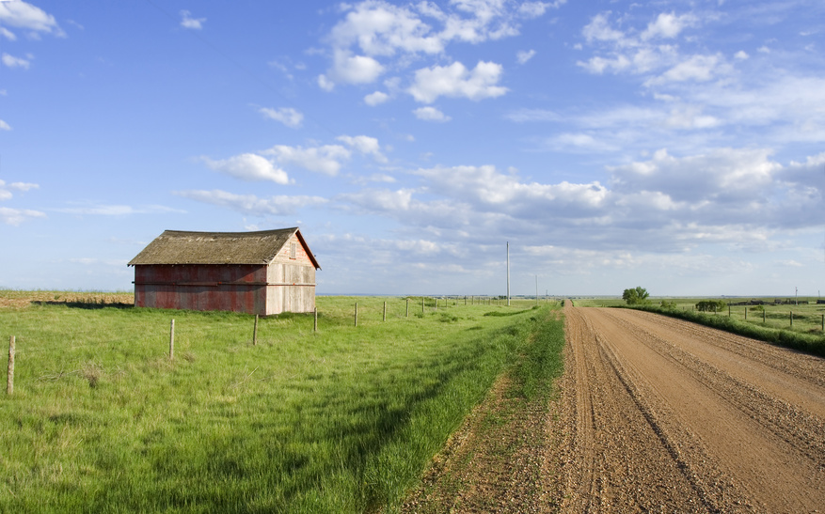

FARM/CROP MEETING

***JOIN US FOR A FREE BREAKFAST MEETING…***

WHEN: Wednesday, January 7, 2015

WHERE: Champaign County Farm Bureau Auditorium

801 N. Country Fair Dr., Champaign, IL

TIME: 7:30 A.M. Registration/Breakfast

11:00 A.M. Adjourn

 • ***Markets: Where to go from here?***

Presented by Cory Winstead - Manager with AgriVisor, LLC

•  ***Farm Bill 2014: What You Need To Know***

Presented by Doug Yoder - Senior Director of Affiliate and Risk Management, with Illinois Farm Bureau

The meeting is **FREE**. ADVANCE Registration is requested.

Please call: Your COUNTRY Financial® representative or

Champaign County Farm Bureau at 217-352-5235 to reserve your spot.

This is a no-cost, no-obligation educational seminar and insurance sales presentation. COUNTRY Financial® and its representatives do not recommend or endorse third party speakers. Policies issued by COUNTRY Mutual Insurance Company®, Bloomington, IL., an equal opportunity provider.

 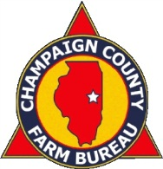  [](http://www.ilfb.org/)

1114-118